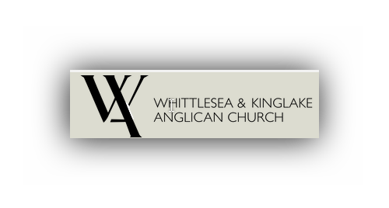

**Registration form: Community Healing Arts Project**

Name ………………………..

Email.……………………………….

Company: ……………………………..

Title: …………………………………..

Address: …………………………………….

Phone: ……………………………..

Cell phone: ………………………………

How many will attend? …………………………

Which Workshop(s) will you attend? (Please tick) ……………………………………………………………….

|  |  |  |  |  |
| --- | --- | --- | --- | --- |
| Workshop | Age group | Venue | Dates | TICK |
| Nexus Primary Health  Workshop: Creative Writing |  | St Peters Kinglake  Cnr Bald Spur Rd and  Whittlesea-Kinglake Road | Saturday 10TH June 8am-12 noon |  |
| Ellimatta Workshop: Mindful Studio Arts | Adolescence | Ellimatta Youth  94 Whittlesea-Kinglake Road, Kinglake | Wednesdays June 7th and June 14th 5-8pm |  |
| Workshop: Wine making | Gender specific- Men only | St Peters Kinglake  Cnr Bald Spur Rd and  Whittlesea-Kinglake Road | June Sat 17th 9am-12 noon. Two other workshops will be required in July and August to finalise fermentation process. |  |
| Workshop : Colourful Creations | 8-11 yrs. Primary School Age | Ellimatta Youth  94 Whittlesea-Kinglake Road, Kinglake | Mondays June 5th & June 19th 3.30-6.30pm |  |
| St Peters Workshop: Storytelling and Photography |  | St Peters Kinglake  Cnr Bald Spur Rd and  Whittlesea-Kinglake Road | Tuesdays 13th 20th & 27th June 7-9pm |  |
| Neighbourhood House Workshop: 3D Art Form  Heal, Set Goals, Transform |  | Kinglake Ranges Neighbourhood House  6 McMahons Rd, Kinglake | Saturday 27th May 12-3pm; Sat 10th June 12-3pm; Tuesday 20th June 7-10pm & Tuesday 27th June 9.30am-12.30. |  |

Please send the completed form to: barbarawheelerscott@yahoo.com