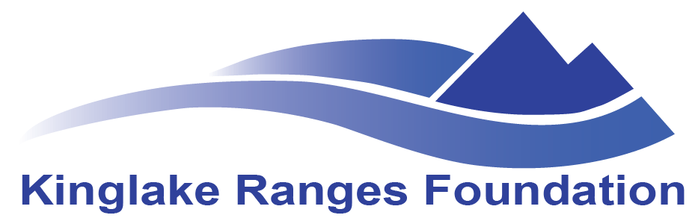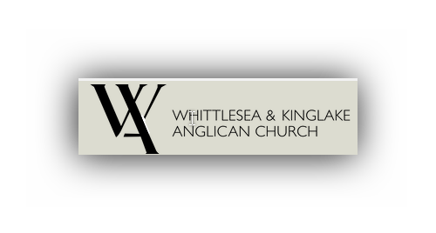
Registration form: Community Healing Arts Project
Name …………………………………………………………………….
Email.……………………………………………………………………
Company: ……………………………..
Title: …………………………………..
Address: …………………………………….
Phone: ……………………………..
Cell phone: ………………………………
How many will attend? …………………………
Which Workshop(s) will you attend? (Please tick) …………………………………………………………….
Workshop | Age group | Venue | Dates | Please Tick
Nexus Primary Health  Workshop: Creative Writing |  | St Peters Kinglake  Cnr Bald Spur Rd and  Whittlesea-Kinglake Road | Saturday 10TH June 8am-12
Ellimatta Workshop: Mindful Studio Arts | Adolescence | Ellimatta Youth  94 Whittlesea-Kinglake Road, Kinglake | Wednesdays June 7th and June 14th 5-8pm
Workshop: Wine making | Gender specific- Men only | St Peters Kinglake  Cnr Bald Spur Rd and  Whittlesea-Kinglake Road | June Sat 17th 9am-12 Two other workshops will be required in July and August to finalise fermentation process.
Workshop : Colour Creations | 9-11 yrs. Primary School Age | Toolangi Primary School Main Road, Toolangi | Mondays June 5th & June 19th 3.30-6.30pm
St Peters Workshop: Storytelling and Photography |  | St Peters Kinglake  Cnr Bald Spur Rd and  Whittlesea-Kinglake Road | Tuesdays 13th 20th & 27th June 7-9pm
Kinglake ranges Arts: Neighbourhood House Workshop: Discover Yourself Through Doll Making and other 3D |  | Kinglake Ranges Neighbourhood House  6 Mcmahons Rd, Kinglake | Saturday 27th May 1-3pm; Sat 10th June 12-3pm; Tuesday 20th June 7-10pm & Tuesday 27th June 9.30am-12.30.

Please Email the completed form to: barbarawheelerscott@yahoo.com

